Ryan, Dan (from SFM Forest Products website and Linked In)

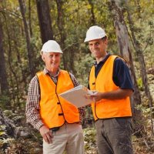

Xavier High School HSC 1985 – 1990. Bachelor of Science (B.Sc.) ANU 1991-1994 ? Bachelor of Economics ANU 1995 – 1996 ?

Forest Operations Manager SFM Forest Products April 2007 – .
Dan is a Forest Operations Manager for SFM in Tasmania. He has 15 years of experience in the forest industry, the majority of which has been in the private sector. He is currently responsible for timber acquisition, landowner negotiations, contractor supervision and sales for both hardwood and softwood properties. He is a Forest Practices Officer (planning) under the Forest Practices Act of Tasmania.

